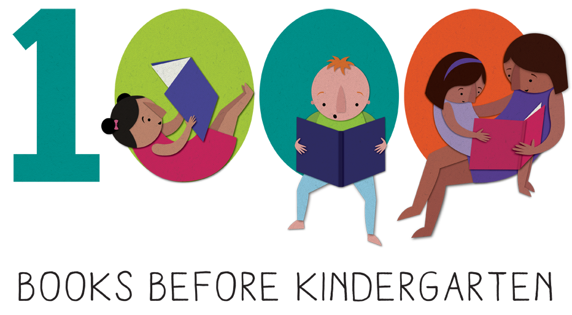


Welcome to the Sims Library 1,000 BOOKS BEFORE KINDERGARTEN PROGRAM!

Did you know that reading to your child is one of the most powerful ways to boost his or her brain power? The simple and enjoyable act of sharing books helps your child learn pre-reading skills such as understanding the sounds letters make, developing a bigger vocabulary, and building background knowledge—all important skills that help prepare your child for learning to read and entering kindergarten.

Sims Library 1,000 Books Before Kindergarten program is a fun, exciting, and free way to start your child on the path to success! Any child ages birth to five years can participate. Just follow these steps:
- Register: Register at the Children’s Desk and pick up your folder or register for the online edition at https://simslib.beanstack.org/reader365
- Track Your Reading: Place a sticker on your reading log for every book you read or scan the book in the Beanstack App.
- Every Book Counts: Even if your child wants to hear the same book again and again, you can count it each time. You can also count the books your child hears in storytime, in daycare or preschool, or with a friend or family member, as long as your child listens to the entire book.
- Milestones: Each time you read 100 books, bring your reading record to the library to receive a special sticker. Take home a new reading record for your next 100 books.
Receive special prizes when you complete 100, 300, 500 and 700 books!
- 1,000 Books: You did it! Come grab your Grand Prize and a certificate of completion!
- Keep on Reading: Don’t stop at 1,000! Keep on reading together; there’s more learning ahead!

Singing songs, saying rhymes, telling stories, and playing with your child are all great ways to build their literacy skills. Visit Sims Library often for free programs that are fun and educational for your little one and to find great books to share with your child.

One thousand books may seem like a lot, but if you read just one book a night, you’ll meet your goal in less than 3 years. If you read three books a night, you could reach your goal in just one year! Ask our friendly staff for suggestions—we’re here to help you on your journey to 1,000 Books Before Kindergarten!

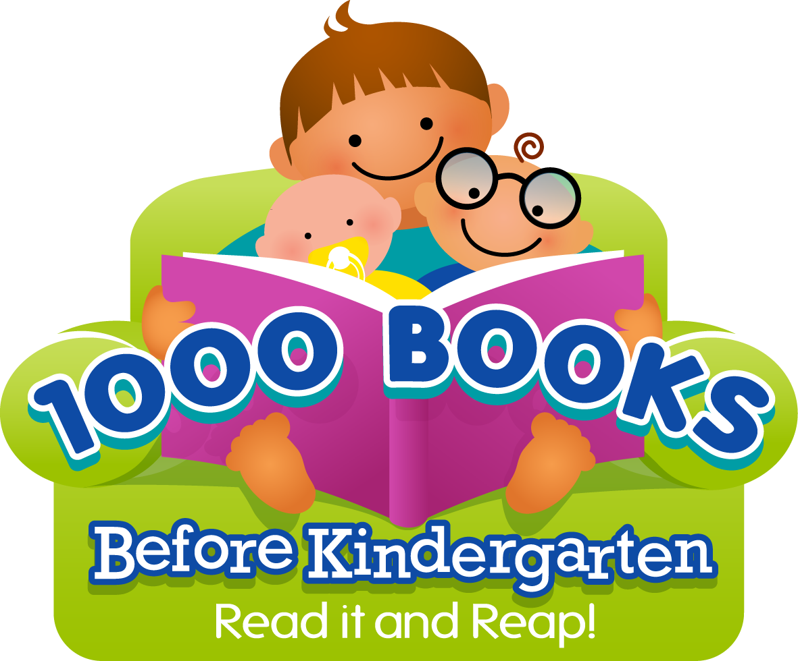
Happy Reading!
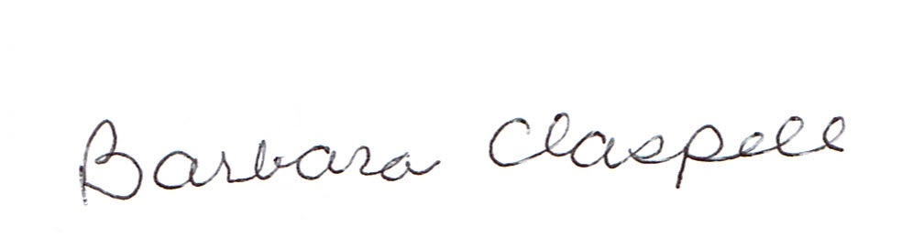
Library Director

